

AEROWORLD:

User guide to design PowerBI visuals

# Introduction

**Power BI** is a powerful data visualization platform that allows you to create interactive charts, dashboards, and analytical reports. In this guide, we will show you how to create different types of visualizations



# Step 1: Prepare the data

## Click “Get Data” > Excel or CSV.

## In the **navigator window**, select **Import mode** when prompted.

## 

## Load a sample dataset and open Power Query Editor

## Simple actions you might need to perform

* Use First Row as Headers if needed
* Change data type if needed

Many other transformations can be used: to create new columns, to split / merge columns, etc.

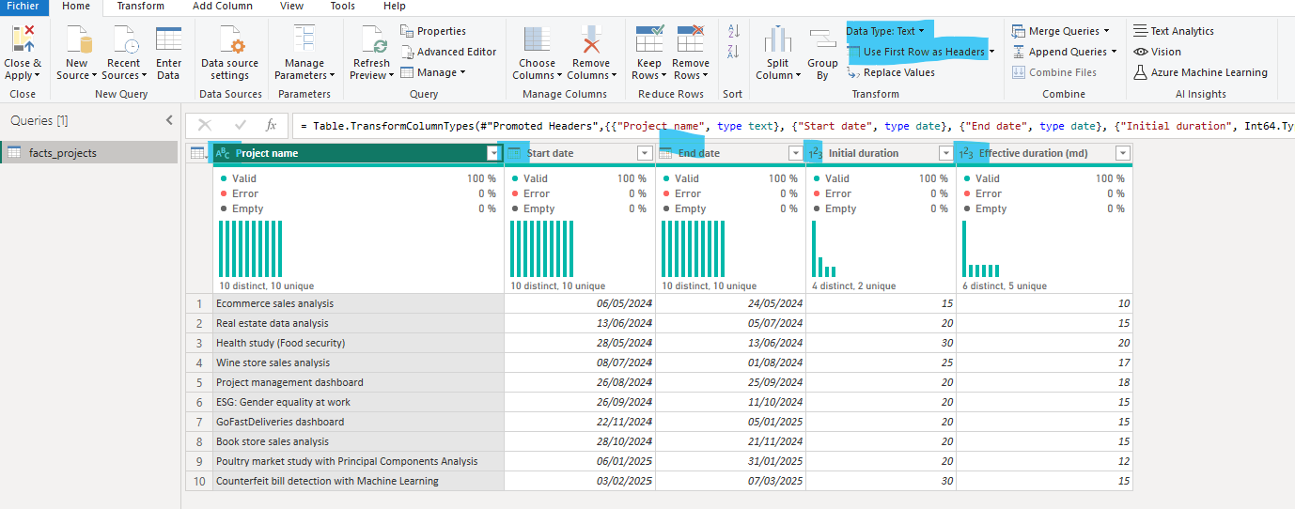

## Close and Apply all changes

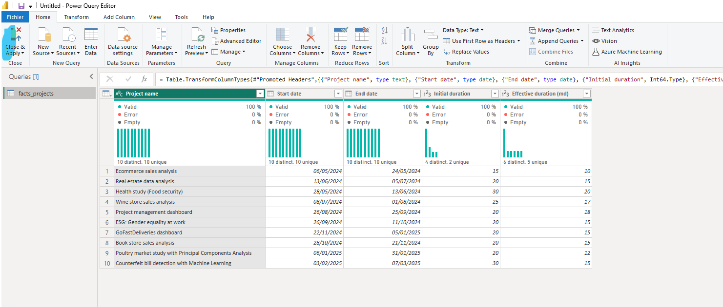

With PowerQuery, you can define the pipeline of all data preparation actions. If updates of initial dataset, you will be able to re-execute all those actions in a automatic way.

# Step 2: Create the visuals needed

## Back in PowerBI desktop, go to Report View

Here you have 3 important sections on the right

1. Filter you can apply to your visual, your page, or the full report
2. Visuals you can select, and customize
3. Data you can use for your visuals

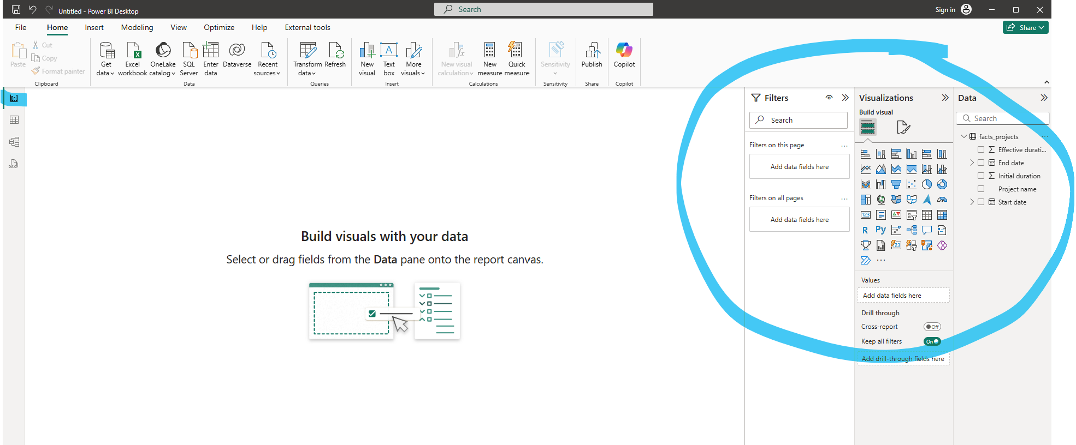

Create a table visual to display 3 columns

* Select the visual “Table”
* Drag and drop data in “Fields”
* Correct data to display: can be renamed for this visual, can be distinct count or else…

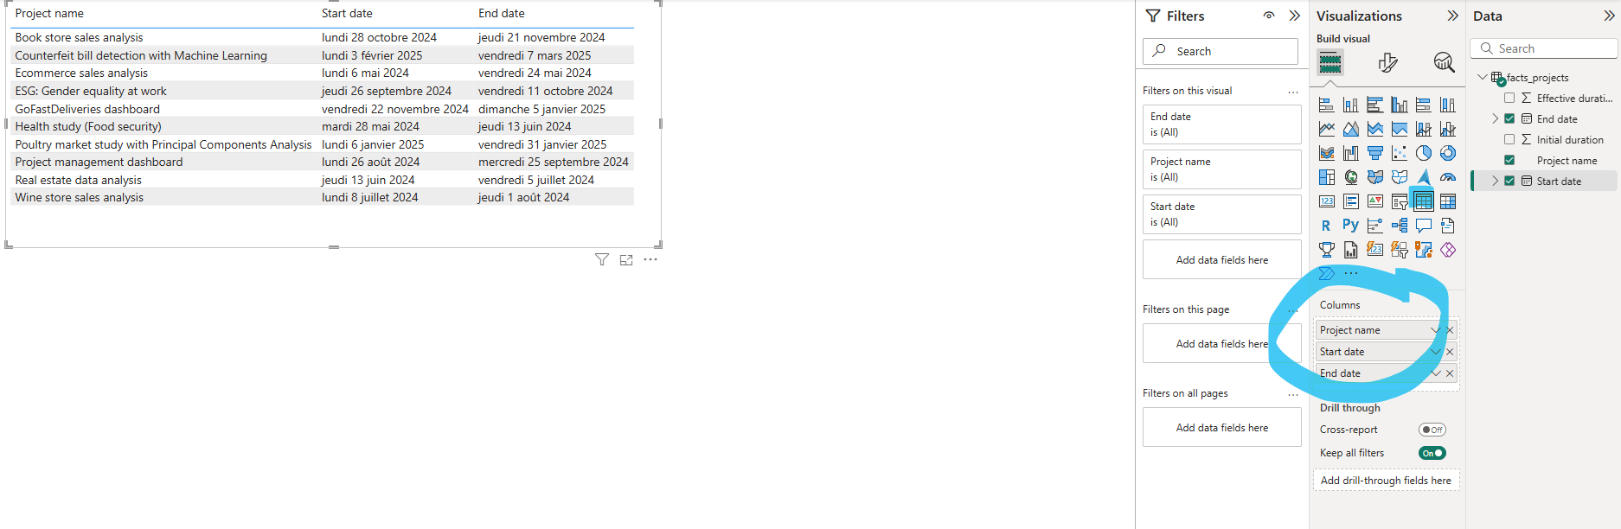

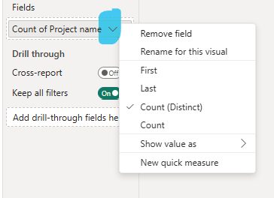

Or create a scorecard to display one unique value

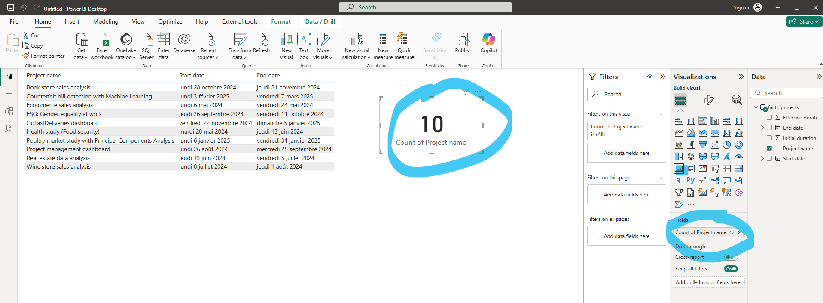

Or create Clustered bar chart

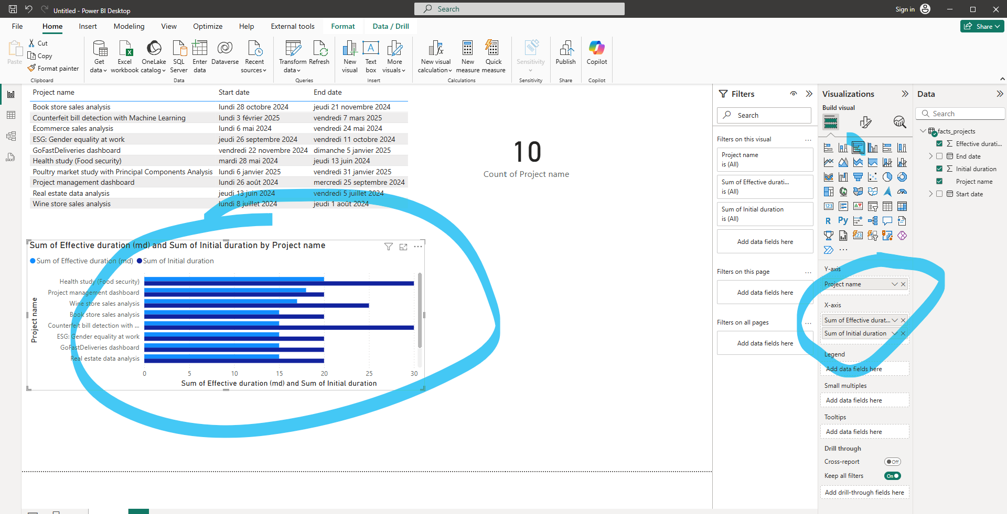

The choice of visuals depends on available data, and story you’d like to tell on those data. In short, PowerBI provides many standard visuals to use. And for each visual, you have different ways to customize them.

* By selecting the right data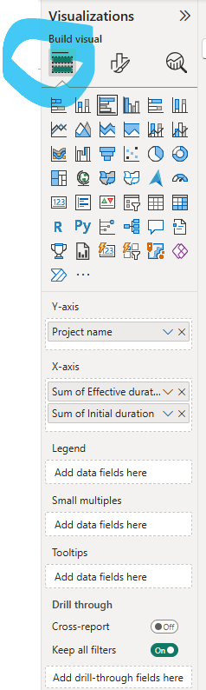
* By customizing different settings of the visual 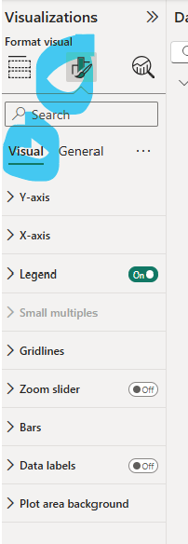
* By customizing the overall display of the visual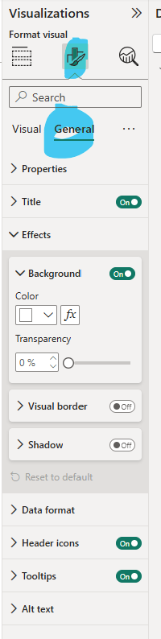

# 

# Conclusion

Power BI is a powerful yet user-friendly tool that empowers users to transform raw data into meaningful insights through interactive dashboards and reports. Whether you're analyzing sales trends, monitoring KPIs, or presenting data stories, Power BI offers the flexibility and functionality to support your needs.

To truly master Power BI, here are a few key tips:

1. **Prioritize Data Preparation**Invest time in understanding your data. Clean it efficiently, automate repetitive steps using Power Query, and structure your data using best practices like the **star schema model**. A well-prepared dataset makes everything smoother downstream.
2. **Leverage the Power BI Community**You're never alone! The Power BI community offers countless tutorials, forums, and YouTube videos. Whatever challenge you face, there’s almost always a solution already shared by someone else.

With a bit of practice and curiosity, you’ll be building insightful dashboards in no time.

